Senior Parking Spots – 2024-2025
Sales will be in the Mall:
Monday July 29th 8am - 11am
Tuesday July 30th 11am - 2pm
Wednesday August 7th 2:30pm (during senior schedule pick up)

Parking spots are purchased on a first come, first served basis.
Spots cannot be reserved without payment and paperwork.

Parking Permit Hangtags:
Students must purchase a parking permit hangtag at the time of purchasing the spot. Students must have a valid driver’s license, current registration, and proof of insurance to purchase the parking permit. Parking permits are $20, if you are paying by check the permit must be purchased with a separate check from the senior spot.

These spots are available ONLY to Seniors and are RESERVED for YOU all year!
Spots must be purchased, approved, and painted BEFORE Friday August 16th.
Submit all paperwork to Ms. Williams at the time of purchase.
A sketch of the spot artwork must be submitted when the spot is purchased.
Please text 727-643-9938 for questions
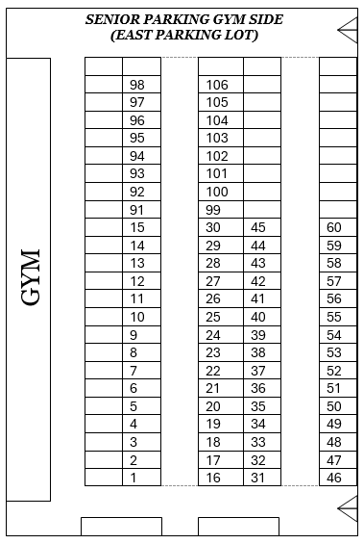
GYM/EAST Side Parking:
Spots #1-60; 91-106 are $60
Parking for SENIORS who have dual enrollment, OJT, or virtual classes.
AUDITORIUM/WEST SIDE PARKING:
Spots # 61 -90 are $60
This parking lot is for seniors who have a FULL DAY schedule. Parking lot gates on this side are locked during school hours.
DISCLAIMER:
All sales are FINAL.
*Please keep in mind that this is a fundraiser for the Senior Class.
100% of the sales go to Senior gifts, Senior events, and Senior experiences.

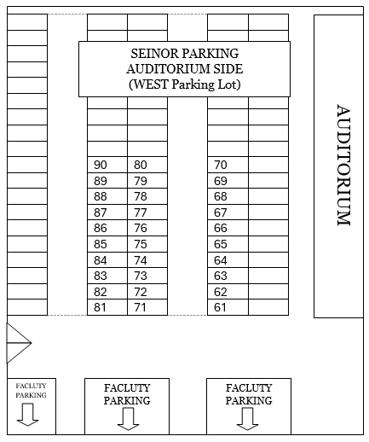

SENIOR Parking Spot Rules
- You must submit your paint design before painting. Your design must be school-appropriate and must be approved before you can paint it.
- All spots MUST be painted.
- You MAY NOT change your design once it has been approved.
- Your design must fit the 50” X 50” square provided. DO NOT GO OUTSIDE OF THE SQUARE.
- Your spot must be painted on Monday – Friday when the gates are unlocked.
- Failure to follow instructions could result in a loss of the spot with NO REFUND.
Pro Painting TIPS:
- Use canned, exterior latex paint. (Lowe’s or Walmart have sample cans that are cheap and plenty for your spot.)
- Do not use spray paint!! Be aware of other cars that are nearby and pay attention to the wind.
- Paint your spot on a dry day – check the weather!
- Use a clear coat sealer to make it last throughout the year!

Spot Design:

Student Name: __________________________________ Student #: ________________
Student or Parent Contact #: _________________________________________________
Parking Lot: ________________ Spot #: ___________

Artwork Approval: _______________________________________Date: ______________
Bottom

